**Class Work: Digital Circuits**

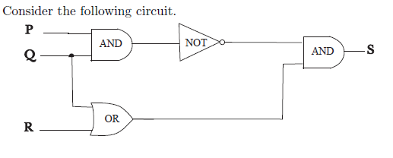

1. Find the output of the circuit corresponding to the input p = 1; q = 0; and r = 1.
2. Find the output of the circuit corresponding to the input p = 1; q = 1; and r = 0.
3. Write the Boolean expression corresponding to the circuit.

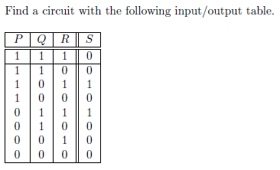

* 1. Consider the following Circuit:

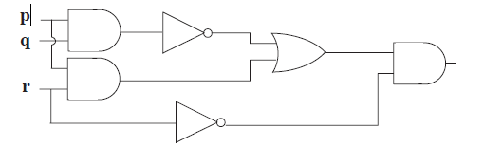

OR

And

And

And

1. Find the output of the circuit corresponding to the input p = 1; q = 0; and r = 1:
2. Write the Boolean expression corresponding to the circuit.

|  |  |
| --- | --- |
| 1. Draw a circuit for the following Boolean expression: |  |



* 1. Using the Circuit below, Find:

1. The output if P=0 and Q=1
2. The Equivalent Boolean Expression

